Telecom Customer Churn Analysis using PySpark

Business Problem
A telecom company wants to understand customer churn patterns and identify factors associated with customers leaving the company.The dataset contains approximately 1 million customer records, making it suitable for demonstrating distributed processing with Spark.
Architecture Design: Podman container
one spark master container
two worker nodes container

Basically in this architecture we have design and shown practically
Distributed Computing: PySpark runs computations in parallel across a cluster, enabling fast data processing.
- Fault Tolerance: Spark recovers lost data using lineage information in resilient distributed datasets (RDDs).
- Lazy Evaluation: Transformations aren’t executed until an action is called, allowing for optimization.
Shown partitions of worker nodes that is 16 partitions in total
1 worker node→8 partition
2 worker node→8 partition

Steps 1: Create podman container and podman network and also directory telcom churn dataset inside that create two subdirectories data and notebooks.

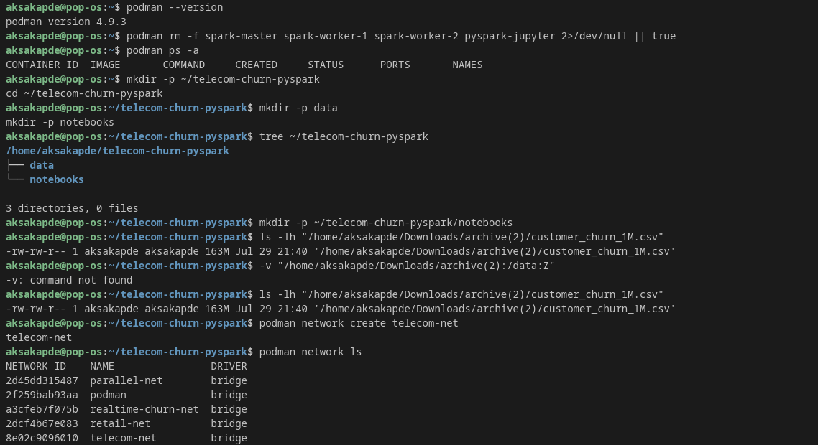
Step 2:pull the image of apache spark from docker then start the apache spark container after that verify on podman we will able to see apache spark image(spark master)

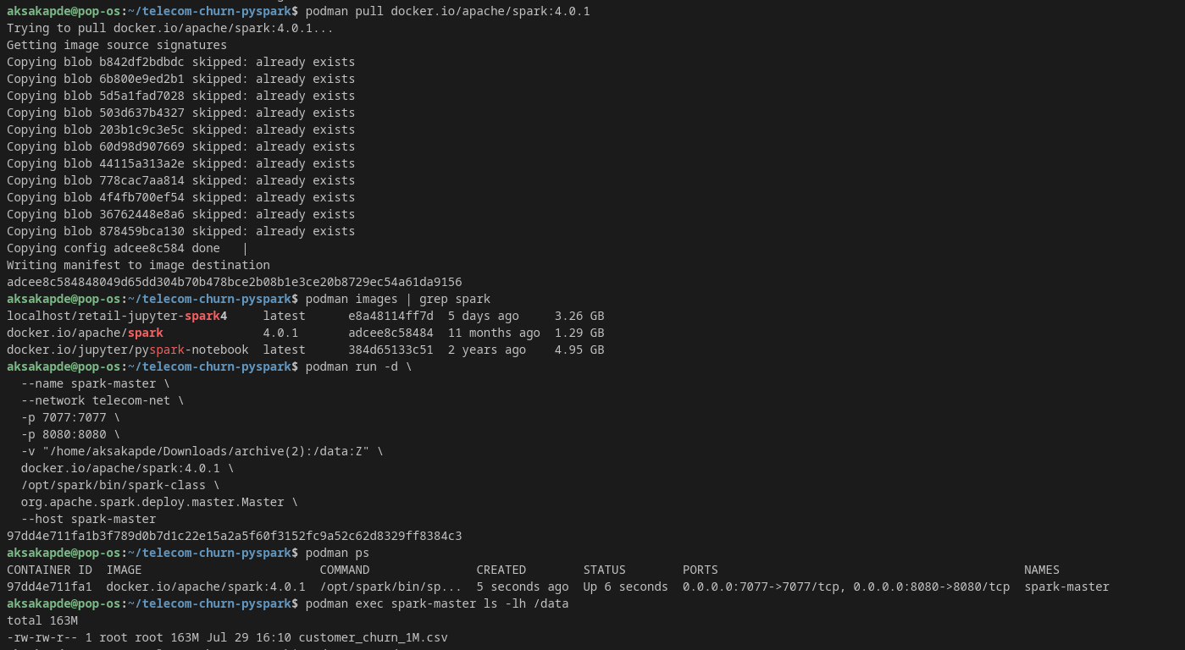

Step 3:Same way Create two spark worker nodes container and also verify on podman ps we are able to see all 3 containers(Spark master, worker 1, worker 2). Also check logs of spark worker 1

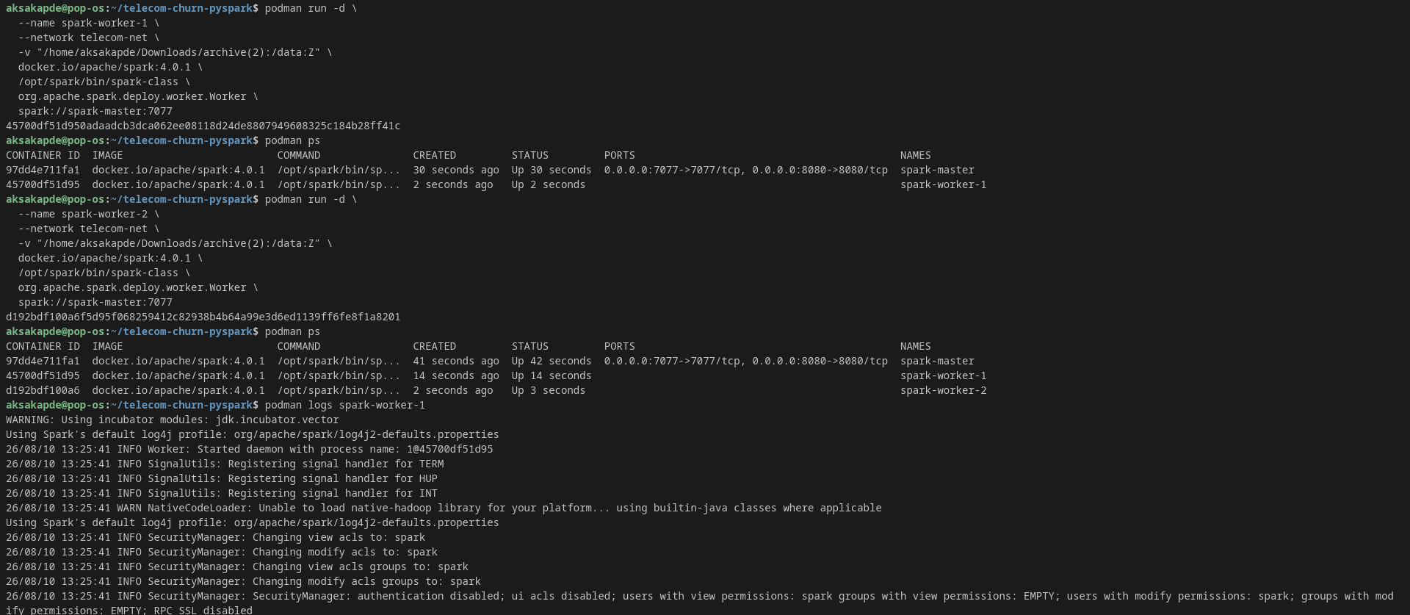
Step 4: Now open spark master you will able to see two worker nodes running in application

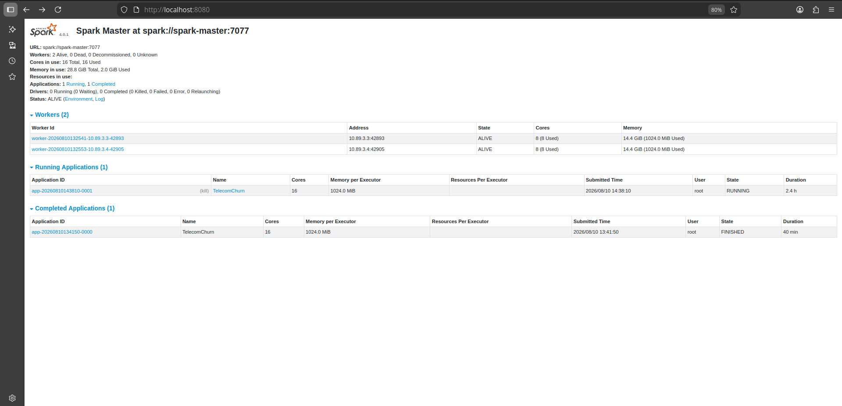
Step 5:we will check logs of worker 2 as well and also data folder which we created why we check because our actual dataset is stored and its need to be mounted to be used with all containers(Spark master, worker node 1, worker node 2). permissions having rw-rw-r.

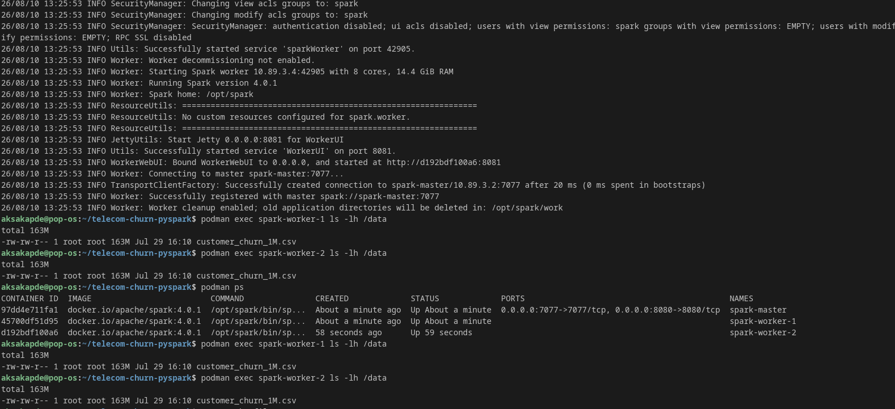

Step 6: we will create nano docker file which contains information jupyter image and pyspark image we need to make sure(all have same version pyspark and python) load the image of pyspark jupyter.

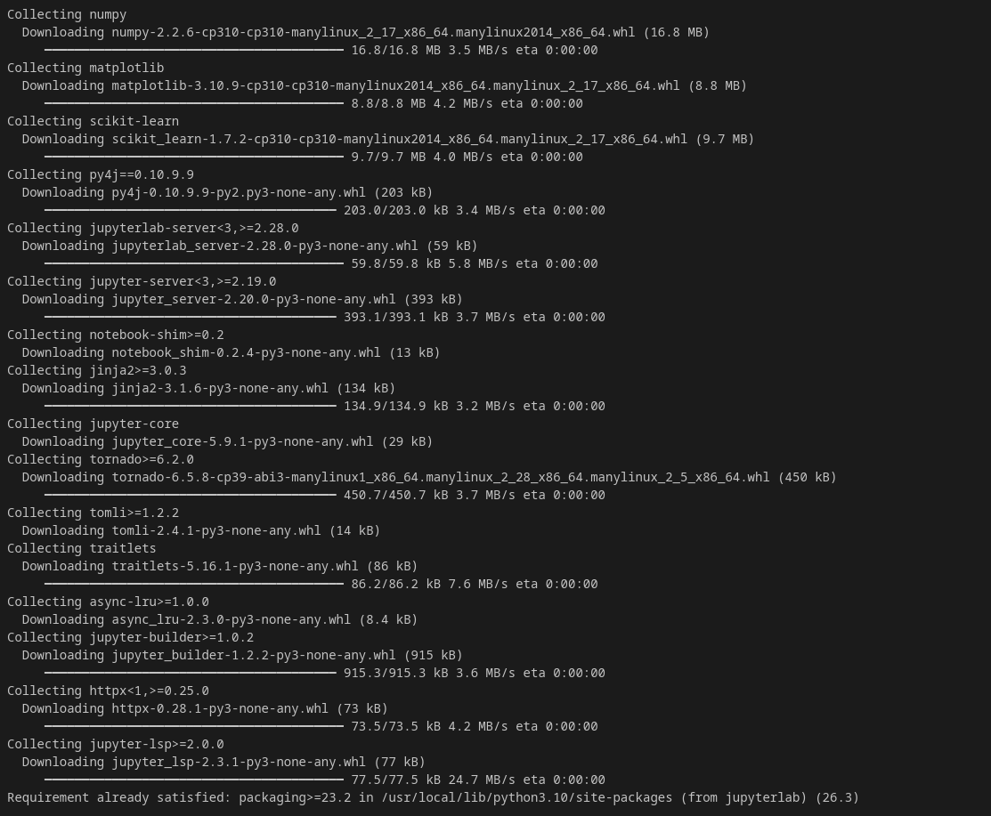
Step 7: create jupyter container and also check the logs

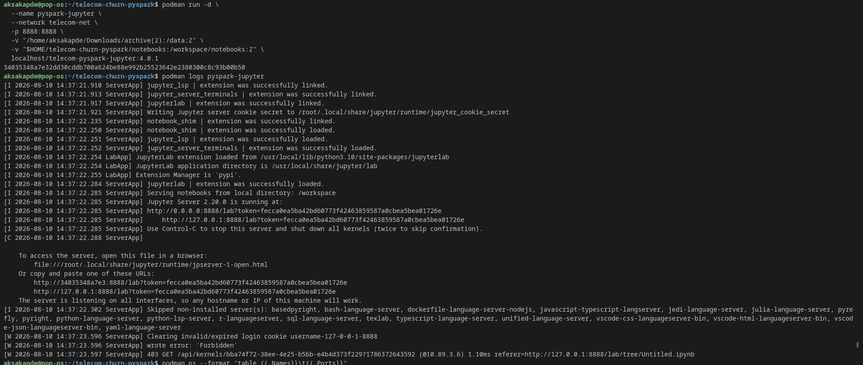

Step 8: check ports for worker nodes and spark master

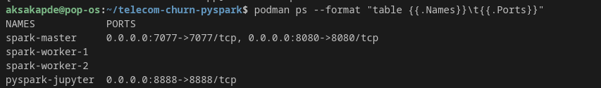
Step 9:Now actual we will show demonstration of Pyspark
we will create RDD and dataframes for distributed processing before that basis of creating pyspark session (starting the spark session means it will show status of running in worker nodes in application id) in spark cluster.

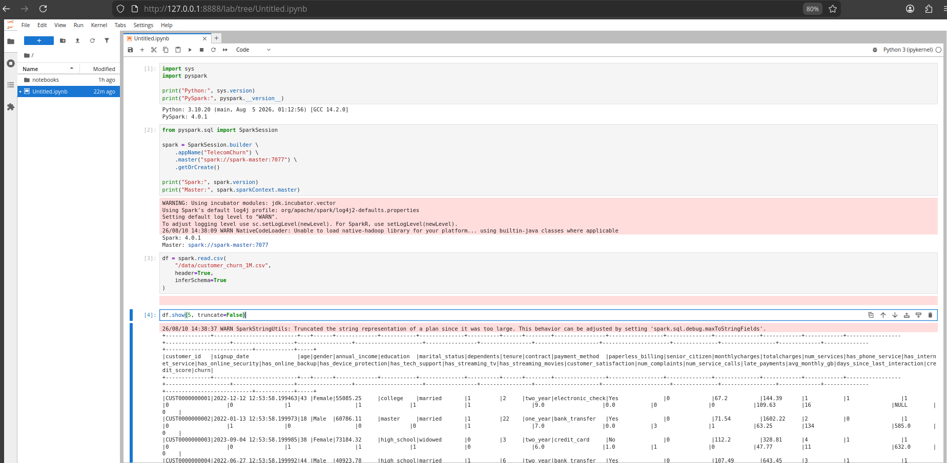

Step 10: Create partitions(which we get 16) so total 8 partitions are divided between two worker nodes means they can process parallely.

Step 11: we will Apply basic RDD Transformations and Actions on pyspark.

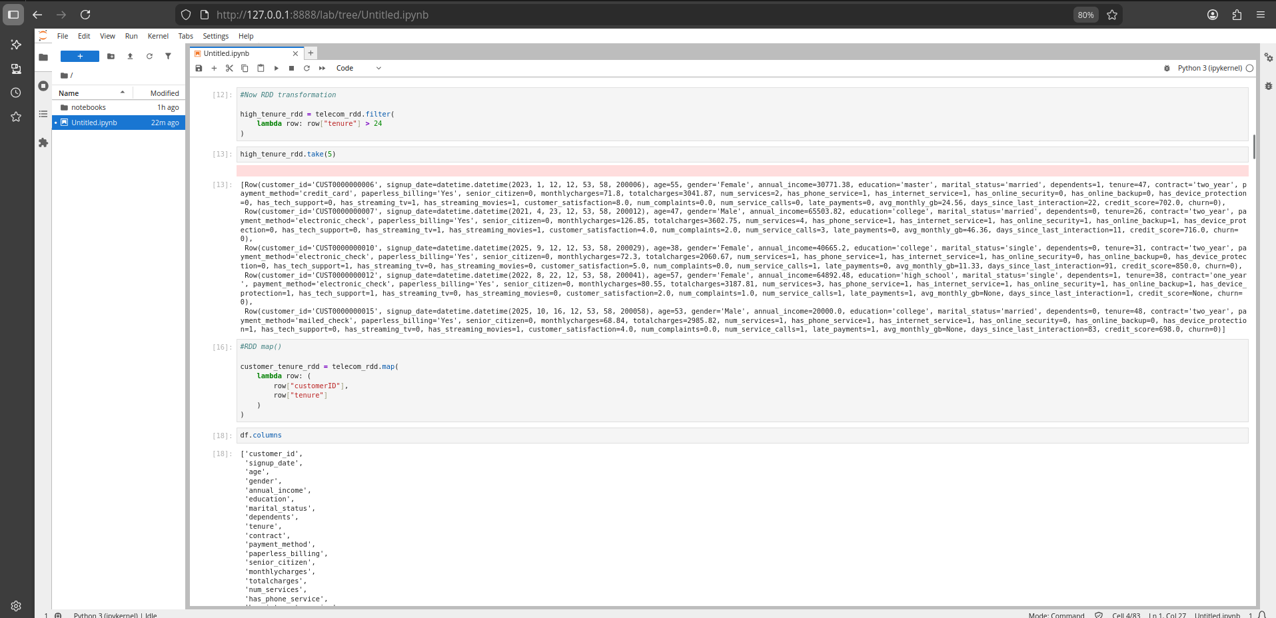

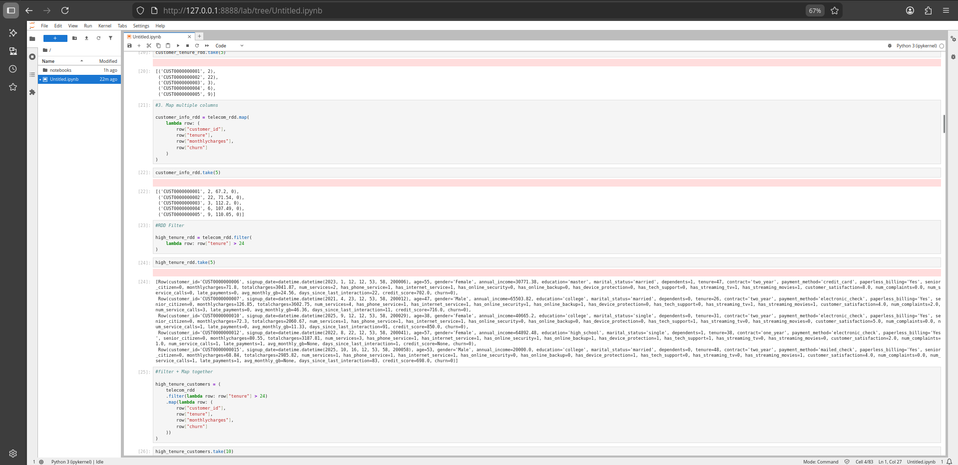

Step 12: We will create Custom schema(why we create it because for real project its gives us data type).

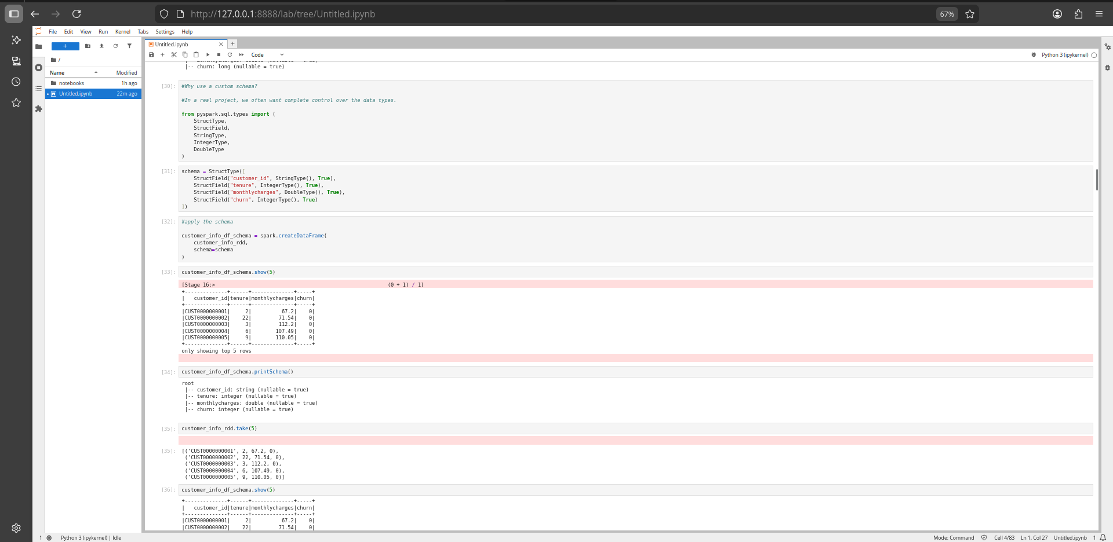
Step 13:Now apply data cleaning and checking null values(if found perform basic median/mean imputation) also used sql functions for filtering, aggregations, ordering and group by.

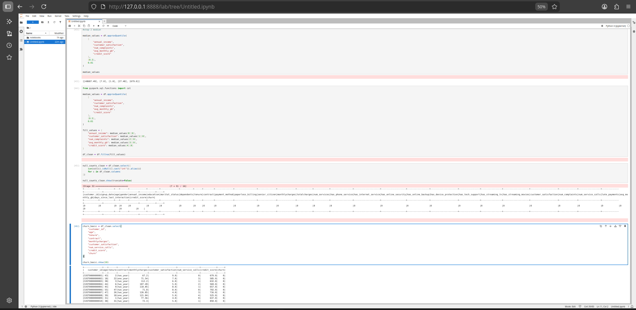

Step 14: Sorting and Order in pyspark

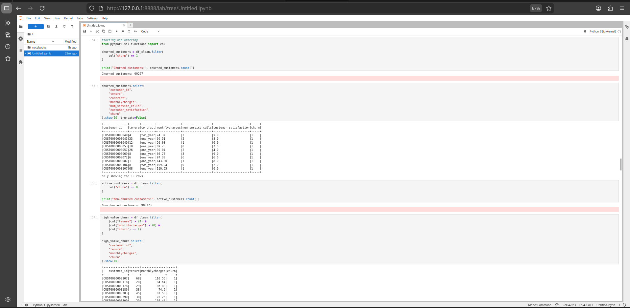
Step 15: used business interpretation customers with highest monthly charges who churned.
Also next we will do group by+aggregation.
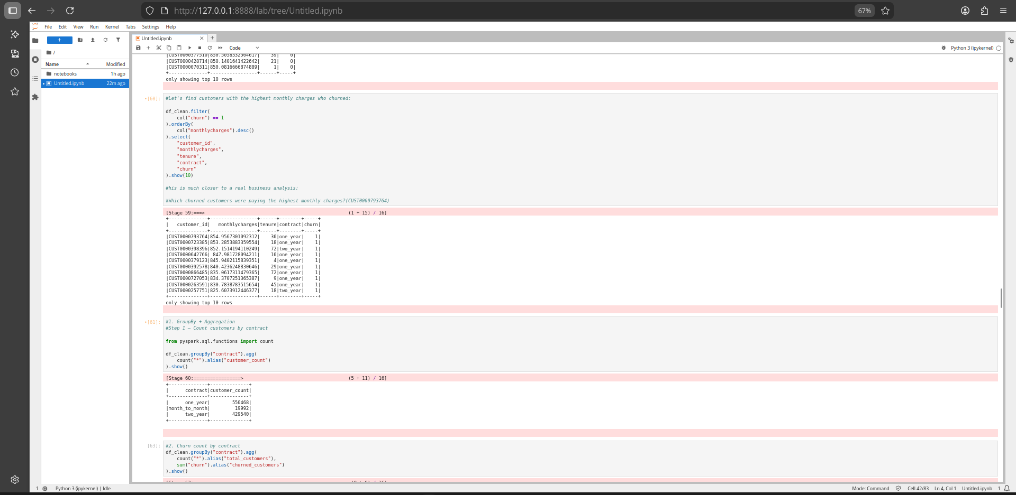

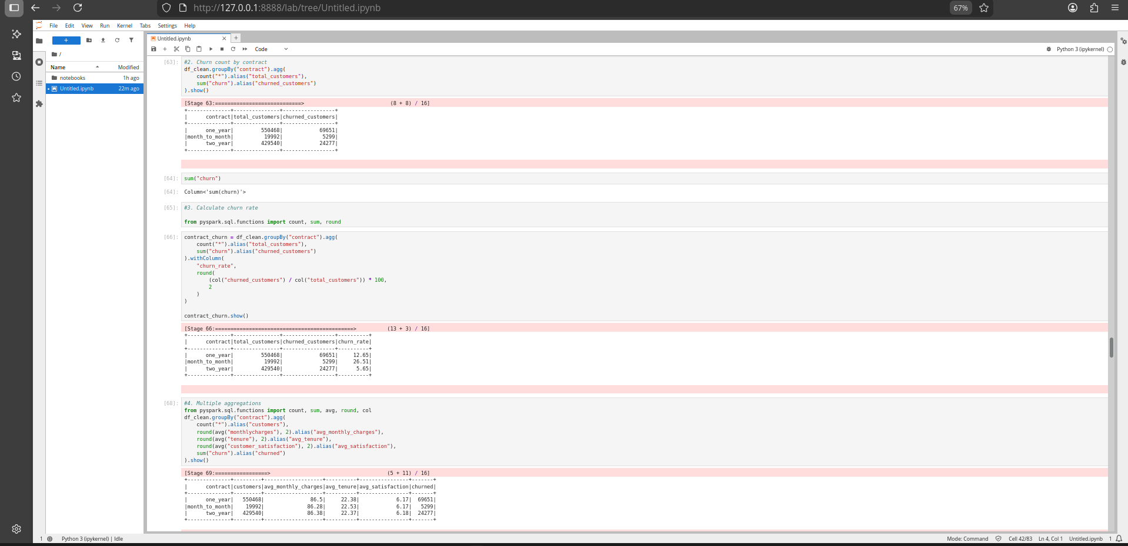
Step 16: Joins in Pyspark(left, right, inner) same it will be divided in partitions so different joins performed by different worker nodes( we create customer_id new to join shuffle data between two worker nodes after running together).

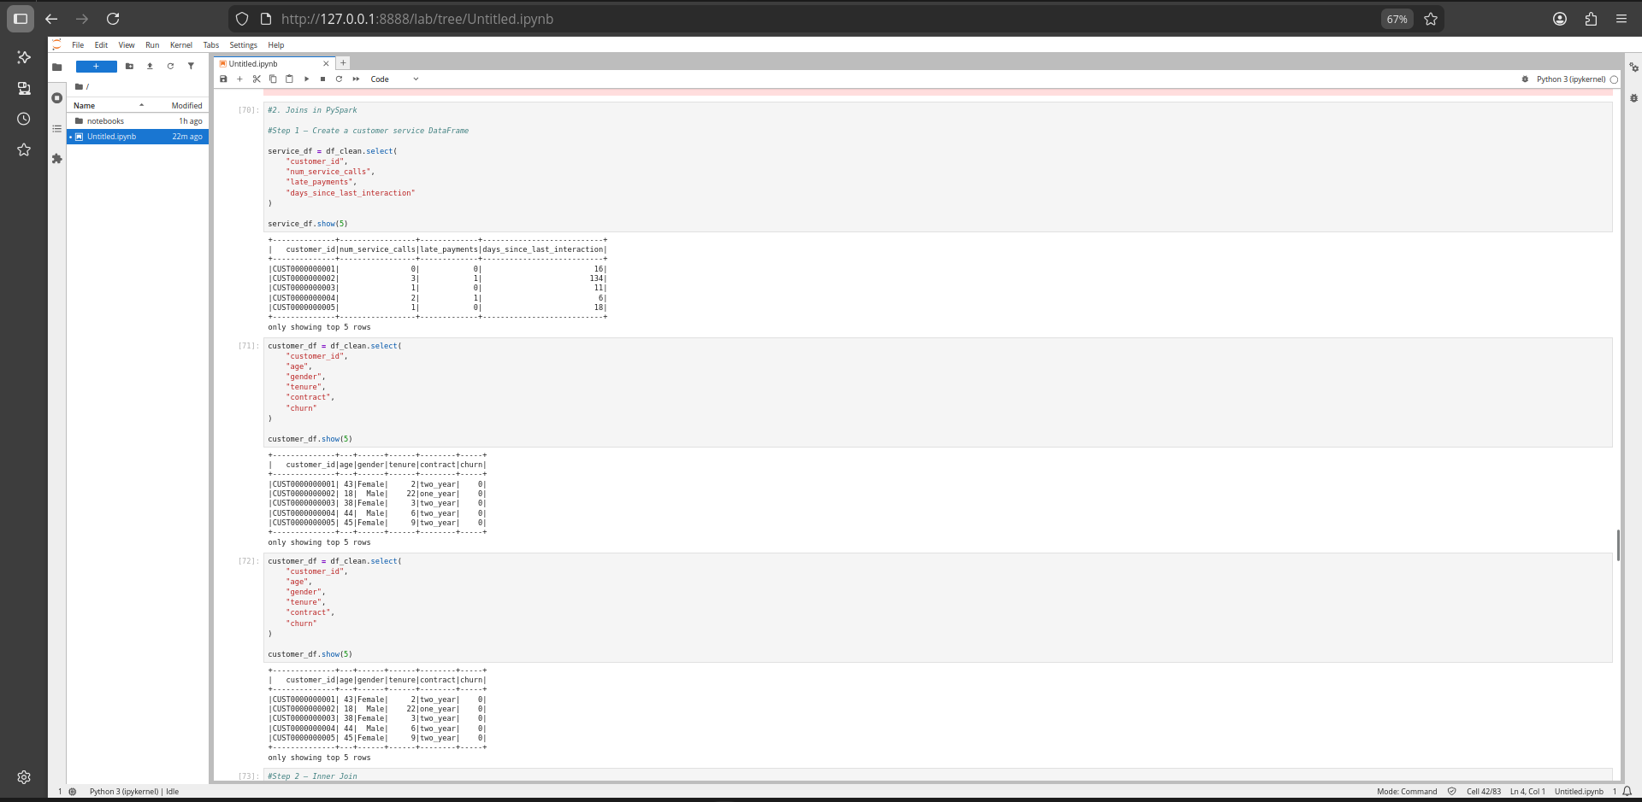
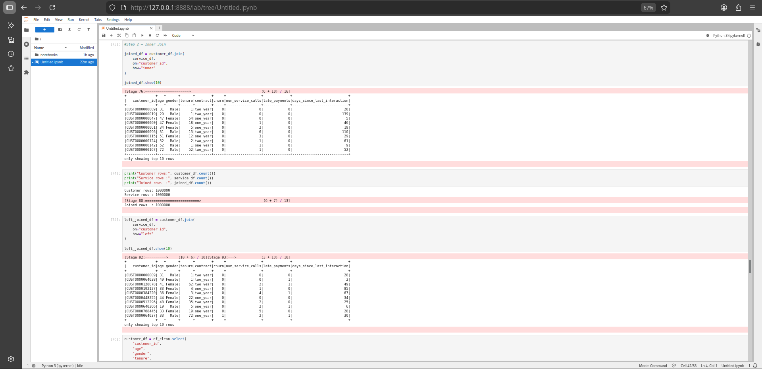
Step 17: we will perform window function

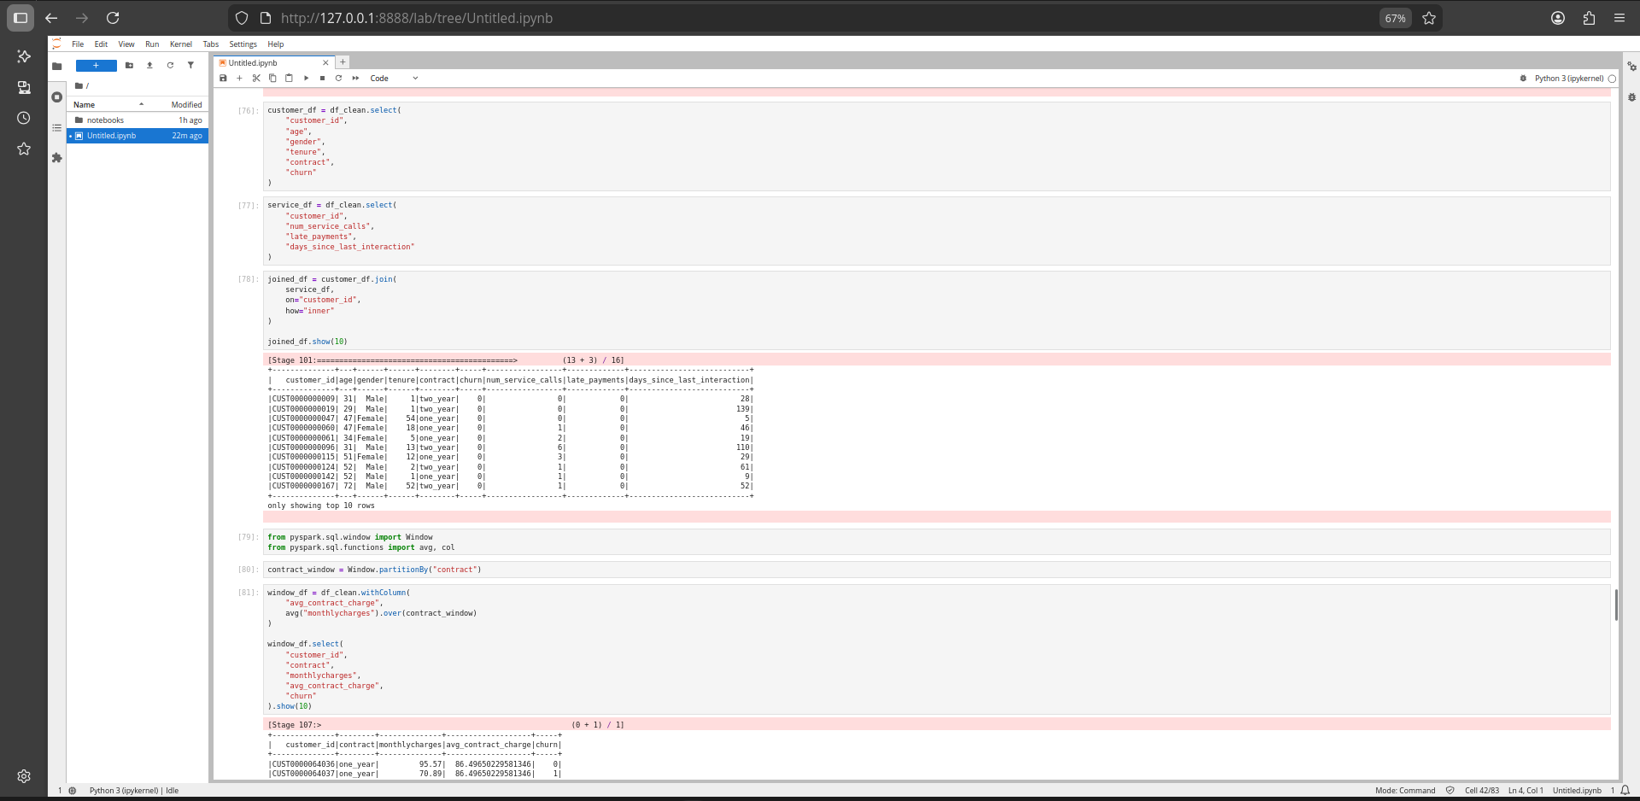

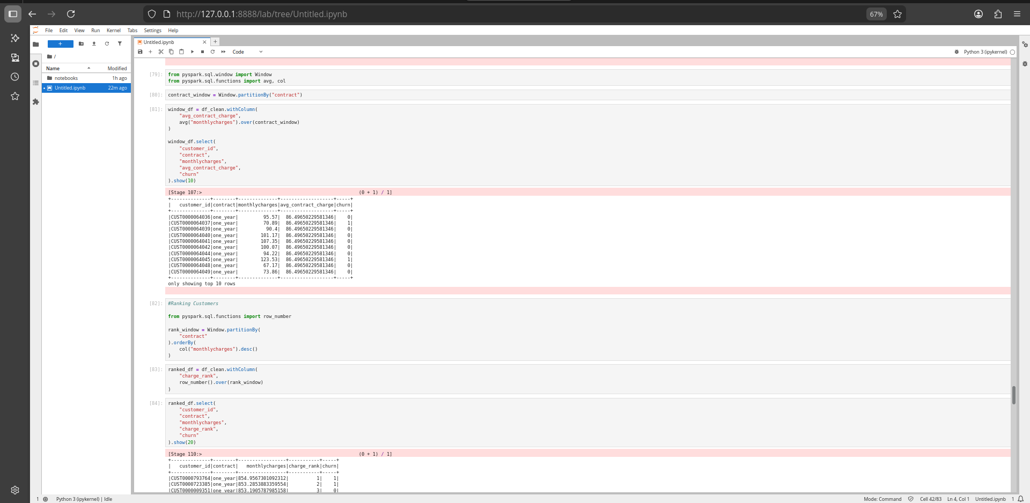
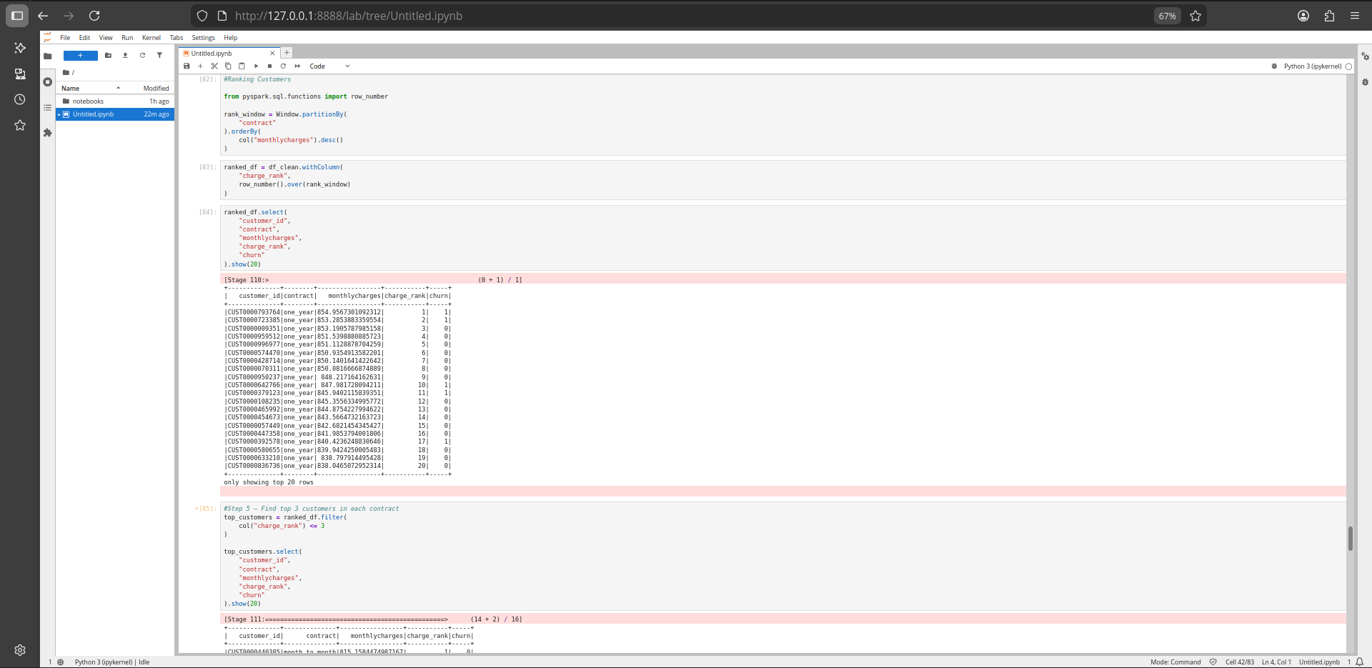

Step 18:Now we will used Spark SQL

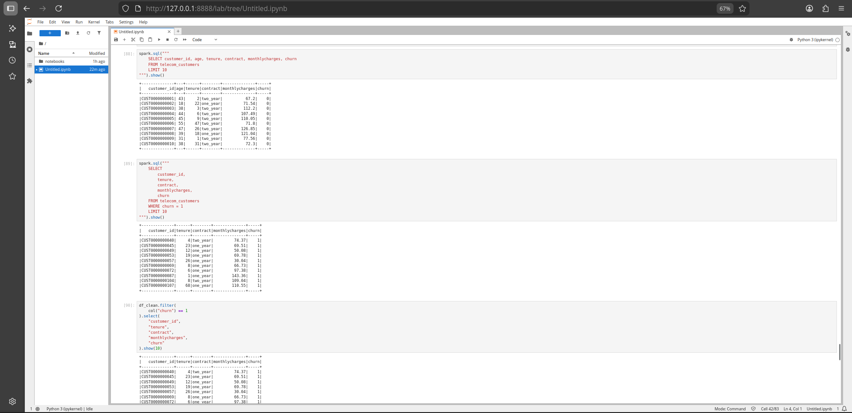

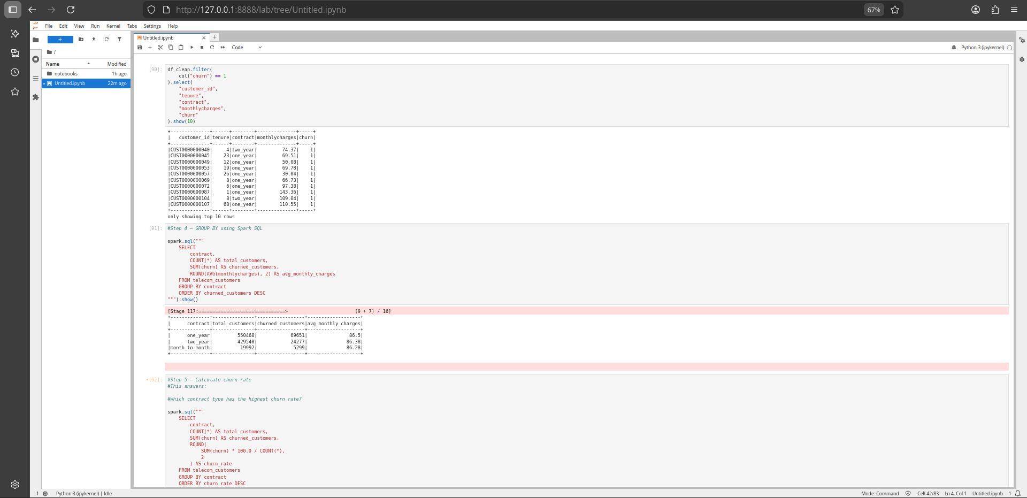

business interpretation which contract type has the highest churn rate?
Similarly we have seen various interpretation of telecom churn in all
RDD why we used because it is used in distributed processing.
Pyspark basics transformations
pyspark sql functions
spark sql

